Problem 2:

Given: Epoch date – 17 Sept, 2021; a) a = 60000 km, e = 0.75, I = 60 deg; b)

Find: a) periapsis, apoapsis, energy, a, semi-latus rectum, angular momentum, [x,y,z] at start; b) plot the three orbital configurations

Assume: Earth point mass model, All RAAN, AOP, and TA, set to values given in GMAT instruction manual

1. a = 60000 km, i = 60 deg, e = 0.75

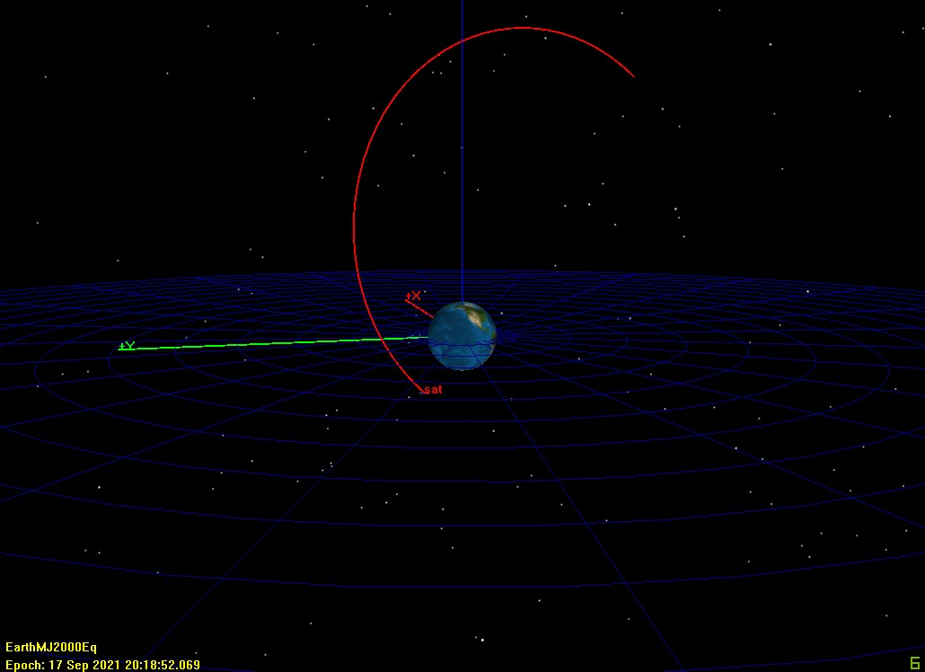

Figure 1 – GMAT Orbit of Satellite from part a

1. Periapsis Radius
   1. Rp = 15000 km
2. Apoapsis Radius
   1. Ra = 105000 km
3. Energy
   1. E = -3.32167034583297 kg\*km^2/s^2
4. Semi-Major Axis
   1. a = 60000 km
5. Semi-Latus Rectum
   1. P = 26250 km
6. Angular Momentum
   1. [Hx,Hy,Hz] = [-71104.59089498752, -52835.43645781396, 51145.04274456859] kg\*km^2/sec
   2. H = 102290.0854891372 kg\*km^2/sec
7. Cartesian Components and Velocity
   1. [x,y,z] = [20335.67334857766, -6912.068196538762, 21131.22867903336] km
   2. [xdot,ydot,zdot] = [1.102798505242097,2.140200795088907, 3.744106357034216] km/s
8. Sat 1 – Red, Sat 2 – Green, Sat 3 – Yellow

i = 0 deg, e = 0.75, a = 35000 km (Sat 1), 60000 km (Sat 2), 85000 km (Sat 3)

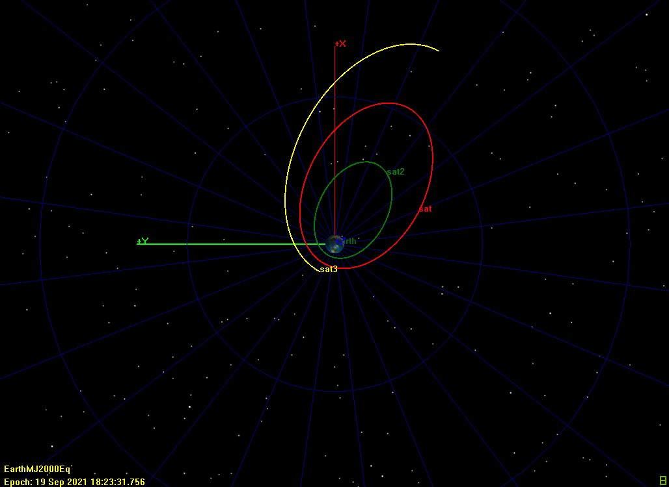

Figure 2 – GMAT Orbital Configuration b1

a = 60000 km, i = 45 deg, e = 0.2 (Sat 1), 0.5 (Sat 2), 0.85 (Sat 3)

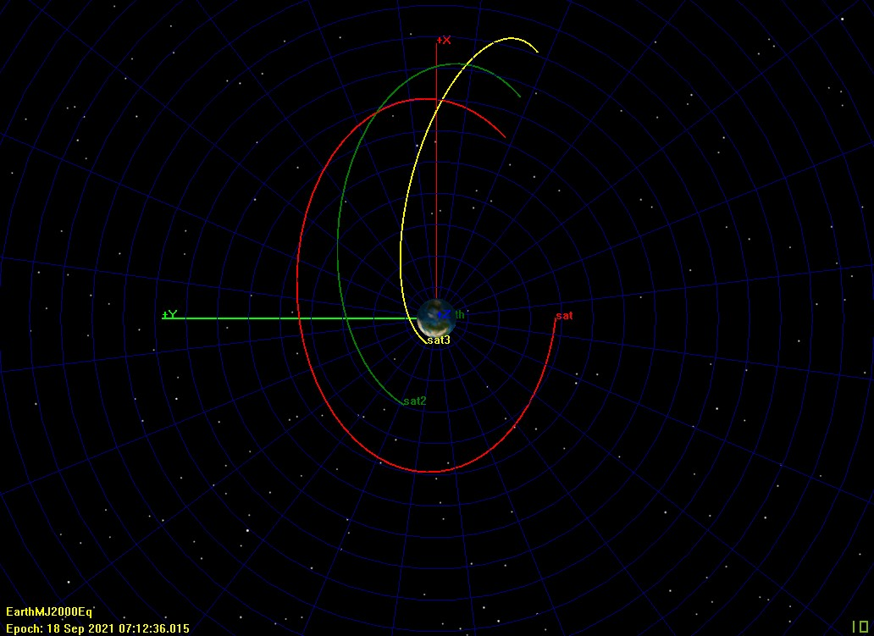

Figure 3 – GMAT Orbital Configuration b2

i = 0 deg, e = 0.6, a = 27500 km (Sat 1), 45000 km (Sat 2), 80000 km (Sat 3)

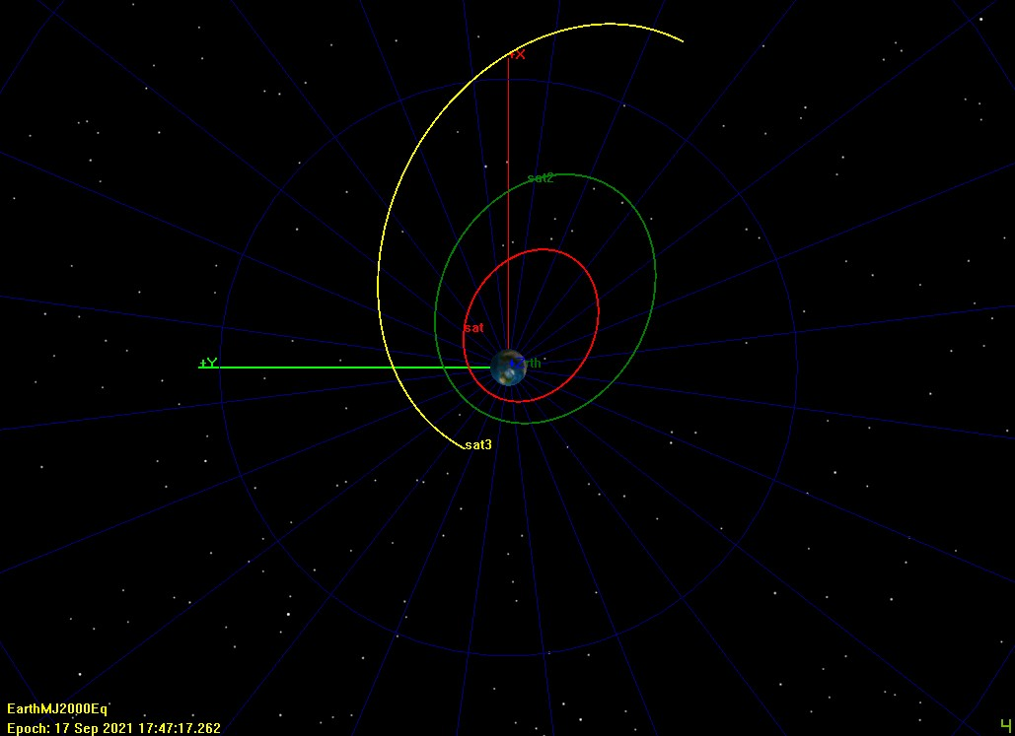

Figure 4 – GMAT Orbital Configuration b3